**DAILY ONLINE ACTIVITIES SUMMARY**

|  |  |  |  |  |  |  |  |  |
| --- | --- | --- | --- | --- | --- | --- | --- | --- |
| **Date:** | **19/06/2020** | | | | | **Name:** | **Archana J C** | |
| **Sem & Sec** | **4th**  **‘A’** | | | | | **USN:** | **4AL18CS011** | |
| **Online Test Summary** | | | | | | | | |
| **Subject** | | **Microprocesses and Embedded System** | | | | | | |
| **Max. Marks** | | **20** | | **Score** | | | **20** | |
| **Certification Course Summary** | | | | | | | | |
| **Course** | **Python and Django full stack web developer bootcamp** | | | | | | | |
| **Certificate Provider** | | | **Udemy** | | **Duration** | | | **2hours** |
| **Coding Challenges** | | | | | | | | |
| 1. **Write a C Program to Count total set bits in all numbers from 1 to n.** | | | | | | | | |
| **Status: Completed** | | | | | | | | |
| **Uploaded the report in Github** | | | | | **Yes** | | | |
| **If yes Repository name** | | | | | **https://github.com/alvas-education-foundation/archana_j_c** | | | |
| **Uploaded the report in slack** | | | | | **Yes** | | | |

Online Test Details: (Attach the snapshot and briefly write the report for the same)

The online test was from module 4, There were 20 questions and the duration was 30 minutes. The questions were optimal and very easy. The score that I got in the test is 20/20.

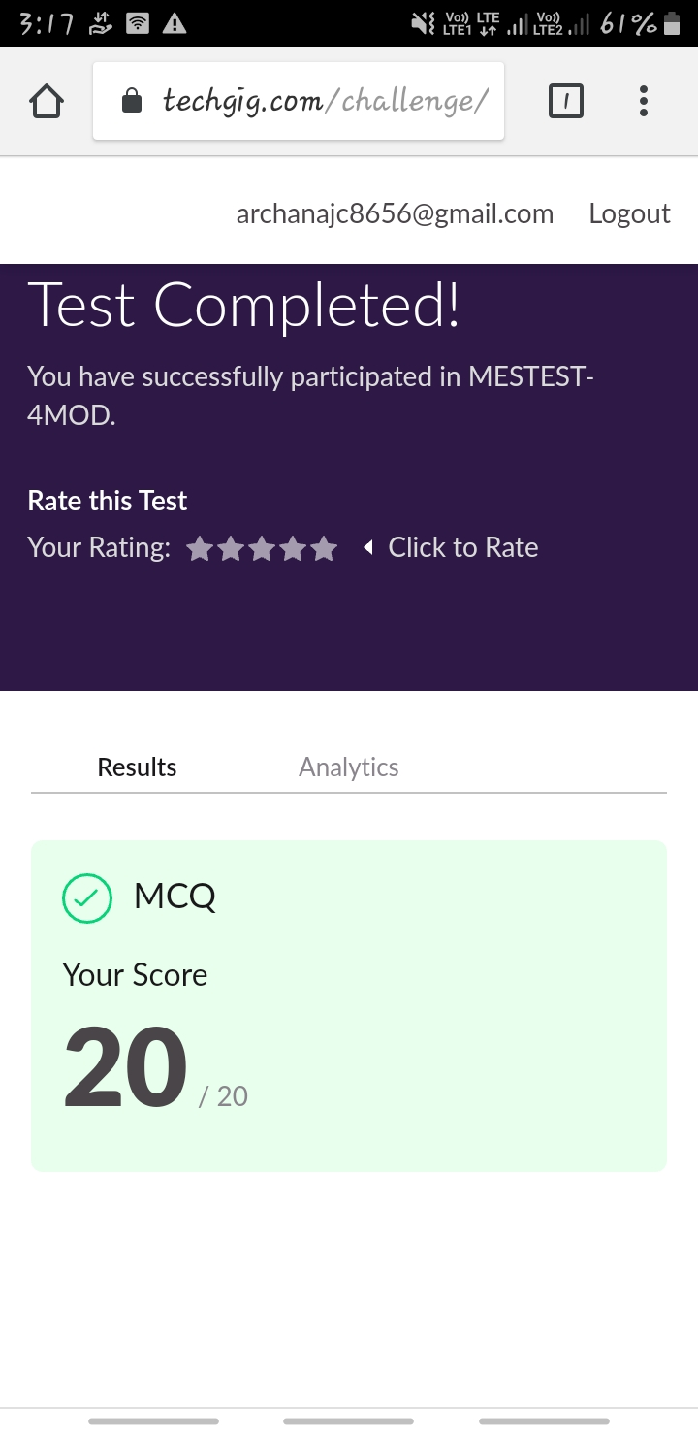

Certification Course Details: (Attach the snapshot and briefly write the report for the same)

COURSE NAME : **Python and Django full stack web developer bootcamp**

CERTIFICATION PROVIDERS : Udemy

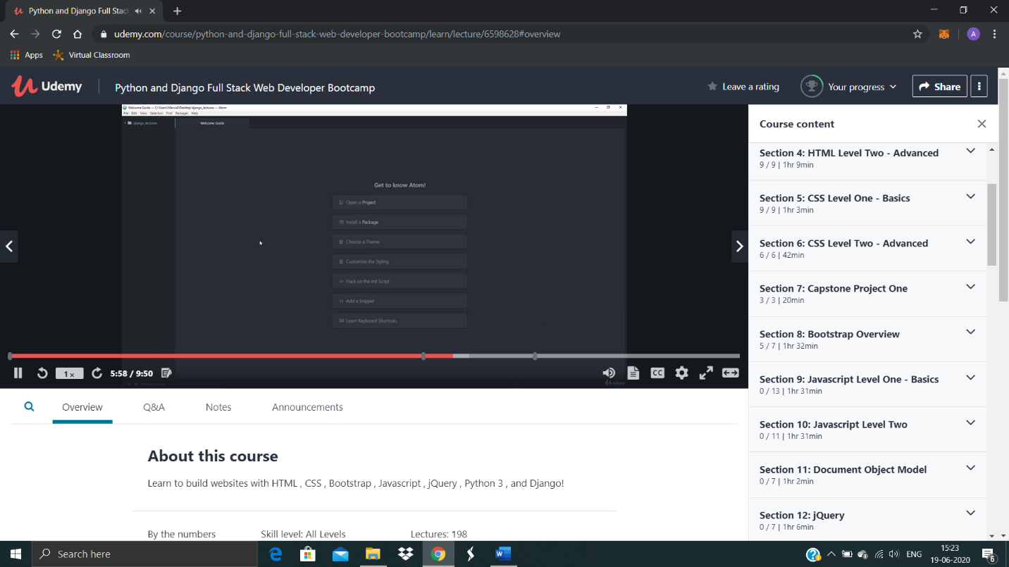

Coding Challenges Details: (Attach the snapshot and briefly write the report for the same)

Today I’m done with some c programs. The solution are already uploaded in github repository.

Program : Write a C Program to Count total set bits in all numbers from 1 to n.

